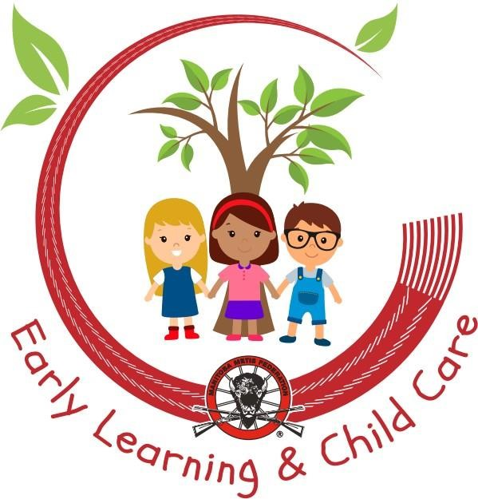
EARLY CHILDHOOD EDUCATION II

MANITOBA

METIS

FEDERATION

IN

PARTNERSHIP

WITH

EARLY

LEARNING

&

CHILD

CARE

DEPARTMENT

METIS

EMPLOYMENT

&

TRAINING

In Person Programs Offered in 3 locations Winnipeg Thompson Brandon

REACH OUT TO US TODAY
elcc@mmf.mb.ca
LRVC@mmf.mb.ca
TO TAKE YOUR NEXT CAREER STEP

